CPT – GREIT Annual Conference
The Implications of Online Platforms and Technology on Taxation and Taxpayers’ Rights

7 & 8 April 2022, University of Amsterdam
We build a tax system of the future with passion for technology and creativity

What you can expect from the event in 2022
The year is 2022 and the world is changing. We embrace change, so we view this as an opportunity to help stakeholders, policy makers and the society to face new challenges with curiosity and creativity and to make informed decisions when addressing issues under the current tax system or introducing structural reforms. That is why we are uniting 36 excellent tax and tech experts to exchange ideas and strive for solutions for what could the tax system of the future look like:
The tax system for a cashless, platform-based and technology-driven society.

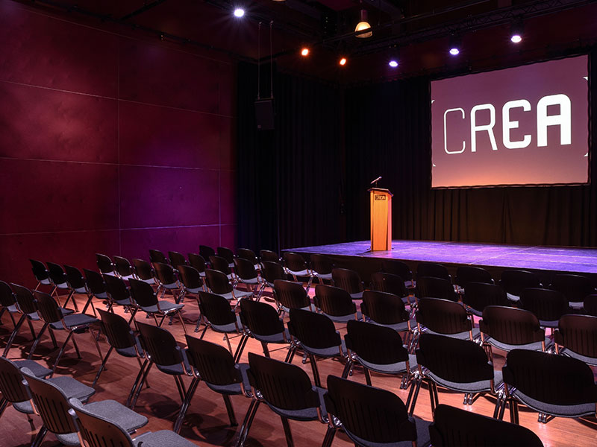
When?
7-8 April 2022, 09:30

Where?
Nieuwe Achtergracht 170, 1018 WV Amsterdam

How to register?
Please register by completing and sending the application form to ACTL-fdr@uva.nl

The main topics for 2022 GREIT Annual Conference
Thirty six speakers and moderators will share their vision of the future of the tax system. The main topics are:
- Implications of platforms and technology on taxation and taxpayers’ rights
- Reporting and due-diligence obligations imposed on online platforms in relation to sellers in the sharing and gig economy
- Online platforms and VAT reporting
- Workforce in the digital era: the legal status of digital workers and its personal and business income tax implications
- The implications of distributed ledger technologies (including blockchain) on tax systems
- Virtual currencies, crypto-assets, NFTs and other implications of de-fi for tax systems
- Explainable AI in tax law
For more Information: Please follow the link to our website or contact Mr. Juan Manuel Vazquez, Academic Coordinator of the CPT project, j.m.vazquez@uva.nl
SPEAKERS AND MODERATORS 2022

- Prof. Dr. Dennis Weber
- Raffaele Russo
- Prof. Dr. Sjoerd Douma
- David Hadwick
- Prof. Dr. Pasquale Pistone
- Jasper van Schijndel
- Dr. Nevia Cicin-Šain
- Juan Manuel Vázquez
- Willem-Jan Van Veen
- Sven Kuipers
- Francesca Vitale
- Roland Rietberg
- Alexander Hent
- Prof. dr. Mariken van Hilten
- Dr. Giorgio Beretta
- Prof. Joachim Englisch
- Prof. Marie Lamensch
- Prof. Marta Papis-Almansa
- Prof. Dr. Ana Paula Dourado
- Dr. Nuria Ramos Martín
- Dr. Svitlana Buriak
- Prof. Dr. Daniel Smit
- Dr. Svetislav V. Kostic
- Shu-Chien Chen
- Prof. Annabelle Gawer
- Dr. Dennis Post
- Dr. Claudio Cipollini
- Sascha Jafari
- Marlies de Ruiter
- Philip Kerfs
- Dr. Luisa Scarcella
- Dr. Błazej Kuzniacki
- Prof. Evangelos Kanoulas
- Marco Almada
- Prof. Anthony Niblett
- Prof Dr. Peter Fettke

